Lab 11

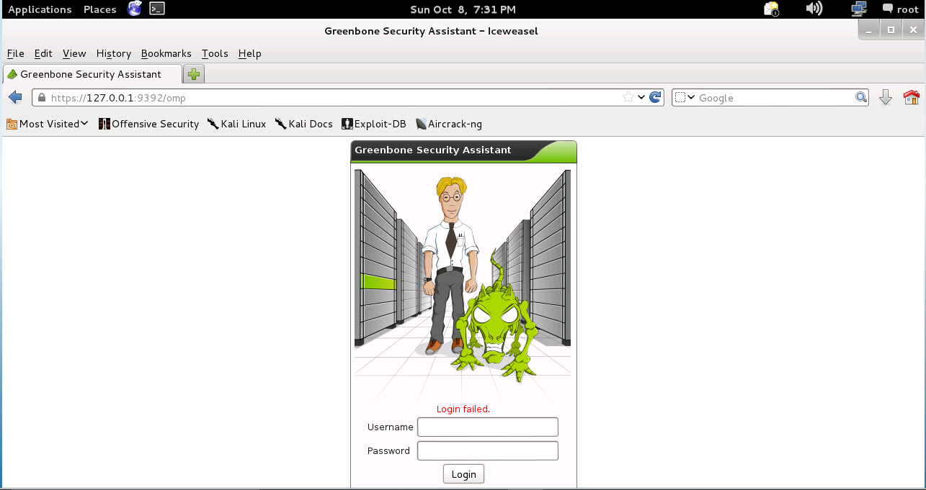

This is as far as I could go on the lab because the log in credentials stated in the lab instructions do not work the log in is not admin admin as is stated I tried the password as password, minda, toor and also looked on the kali forums for help on what the default password was I tried several of the suggestions I found on resetting the password but was unable to have any luck with any of them